Sign in Netlify

Choose a project > Settings > Continuous Deployment

Base directory: client

Build command: npm run build

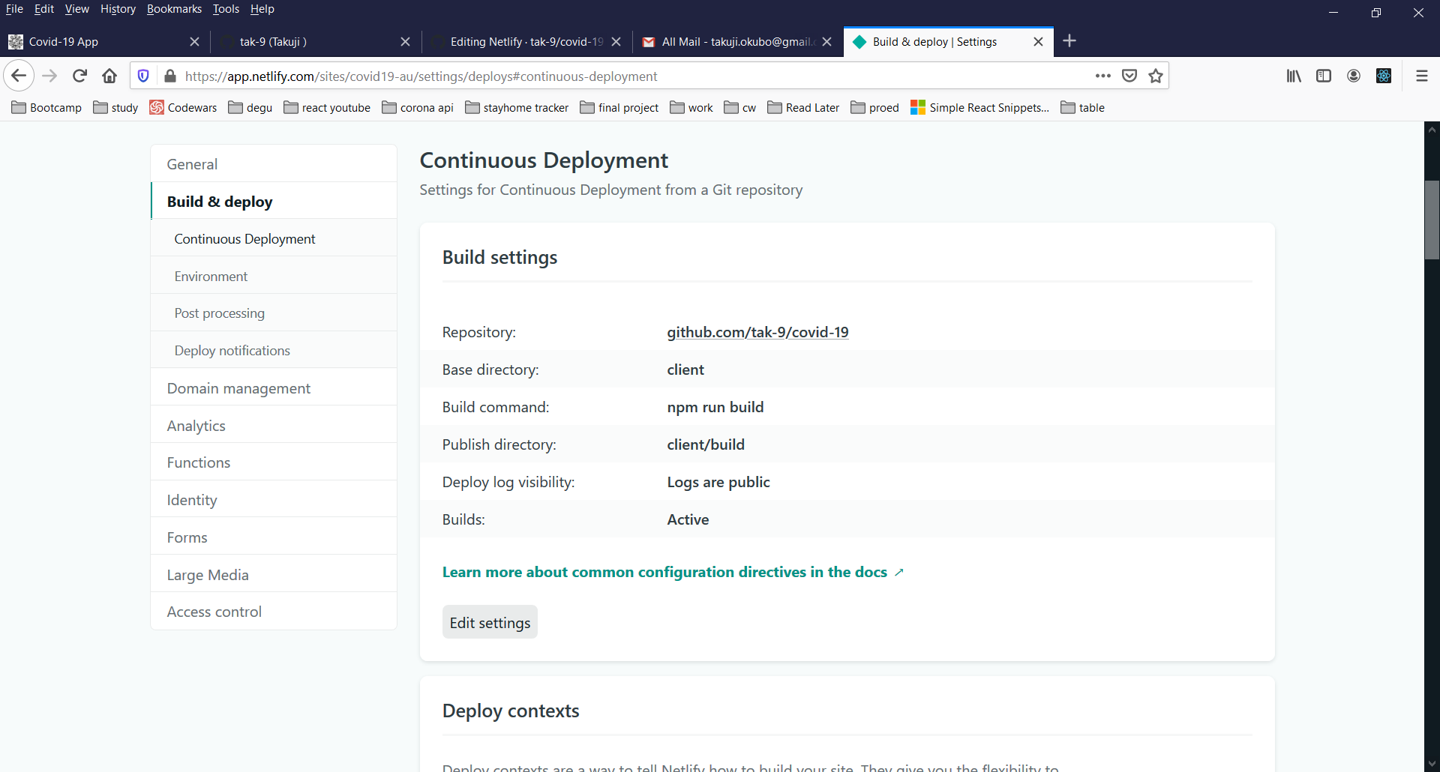

<https://community.netlify.com/t/support-guide-my-site-deploy-fails-unless-netlifys-build-cache-is-cleared/3035>

*Fairly rare but worth mentioning: You have a package.json in your repo root, but you are building a subdirectory of your repo and have NOT appropriately set the base directory in your build settings. That can lead to some confusing caching situations since we’ll only sometimes use that package.json (when there is nocache).*

Base directory must be set. Set as client

If module is missing when built, run “npm install *package-name* –save” in the client directory.

BroserRouter and Netlify

<https://medium.com/@rexben/how-to-fix-page-not-found-on-netlify-with-react-router-dom-e0520692be5>

create _redirects in public directory

In the landing page, useEffect() or componentDidMount()

  useEffect(()=>{

        // Wakeup Heroku when accessed from Netlify

        if (window.location.hostname === "covid19-au.netlify.app") {

            console.log("Accessing https://covid19-au.herokuapp.com/img/login.jpg This is only for netlify");

            axios.get("https://covid19-au.herokuapp.com/img/login.jpg");

        }

    }

  );

Wakeup Heroku when opening landing page.